**DAILY ONLINE ACTIVITIES SUMMARY**

|  |  |  |  |  |  |  |  |
| --- | --- | --- | --- | --- | --- | --- | --- |
| **Date:** | **06-06-2020** | | | | **Name:** | **RAVALI P** | |
| **Sem & Sec** | **6 B** | | | | **USN:** | **4AL17CS076** | |
| Online Test Summary | | | | | | | |
| **Subject** | | **PAP** | | | | | |
| **Max. Marks** | | **30** | | **Score** | | **23** | |
| Certification Course Summary | | | | | | | |
| **Course** | **DATA STRUCTURES AND ALGORITHMS IN C++** | | | | | | |
| **Certificate Provider** | | | **UDEMY** | **Duration** | | | **2.5HRS** |
| Coding Challenges | | | | | | | |
| **Problem Statement-one python program and one c program.** | | | | | | | |
| **Status:Executed** | | | | | | | |
| **Uploaded the report in Github** | | | | **Yes** | | | |
| **If yes Repository name** | | | | **https://github.com/Ravalipr/Daily-Status.git** | | | |
| **Uploaded the report in slack** | | | | **Yes** | | | |

Online Test Details: (Attach the snapshot and briefly write the report for the same)

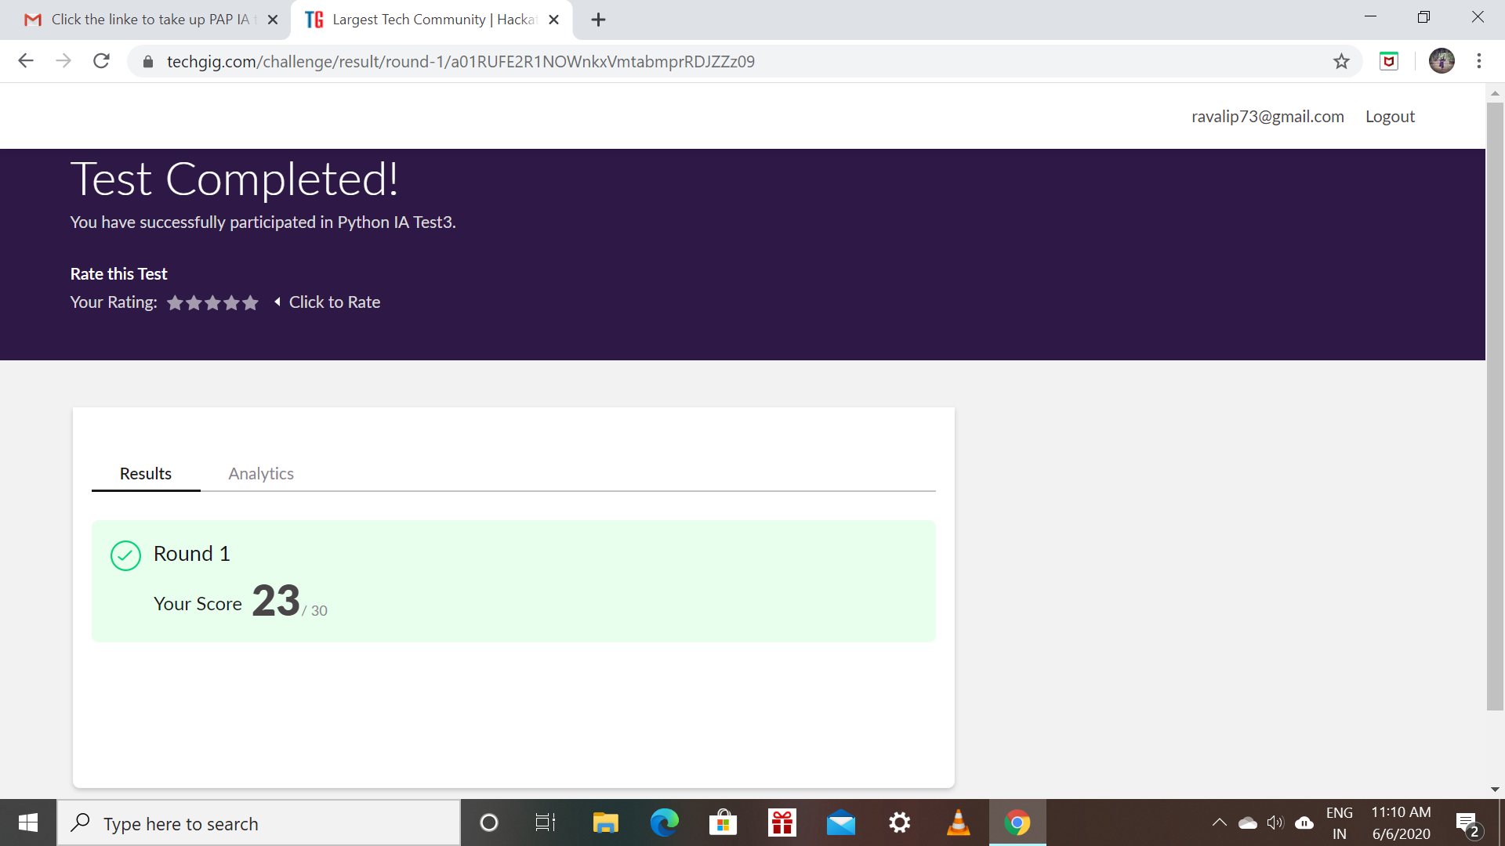

Certification Course Details: (Attach the snapshot and briefly write the report for the same)

* Today taken the course in udemy for learning the Data structures and algorithms in C++.
* Completed the course and answered the final quiz and got the certificate from udemy.

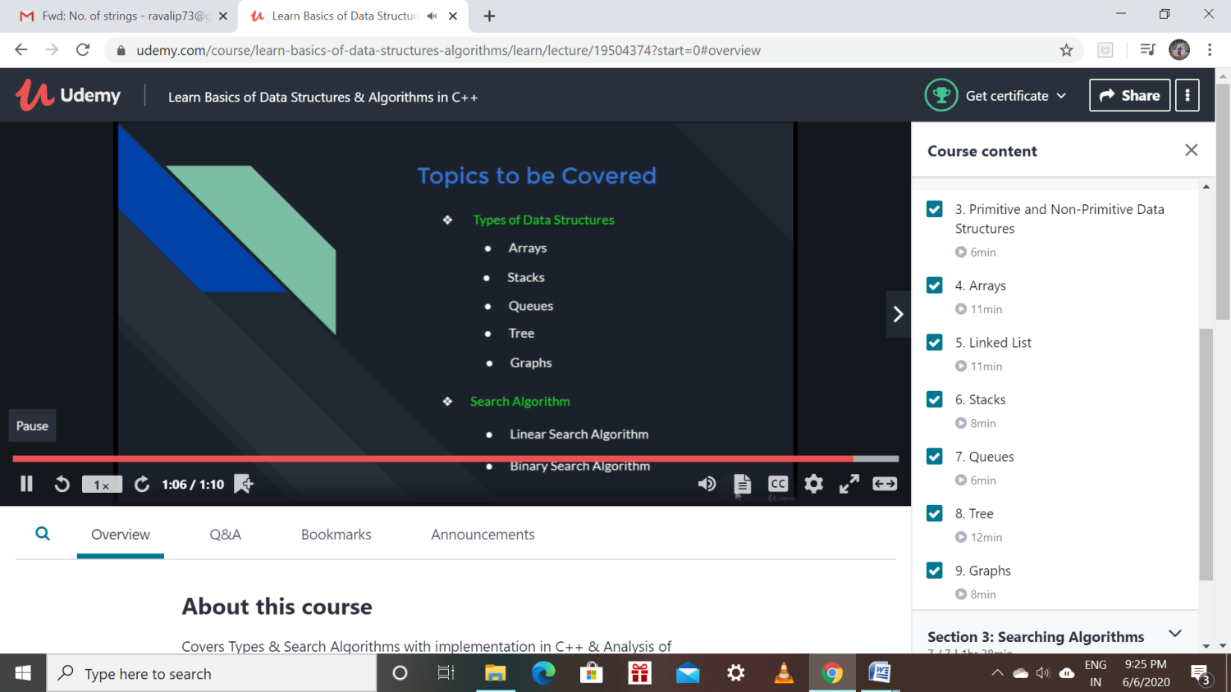

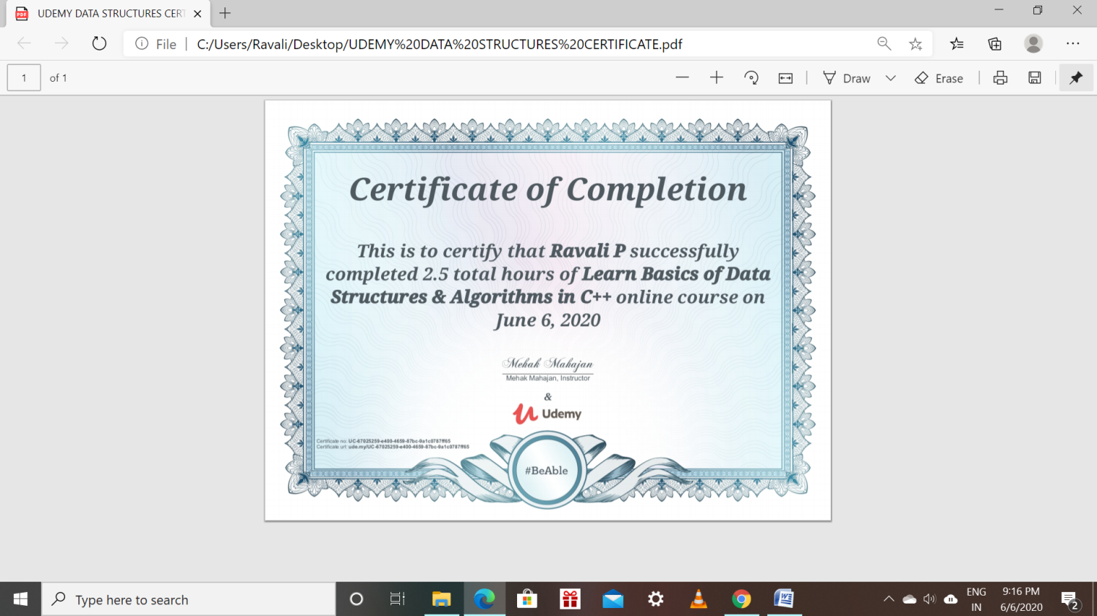

Coding Challenges Details: (Attach the snapshot and briefly write the report for the same)

Program1:

1. Write a program in C to rotate an array by N positions.

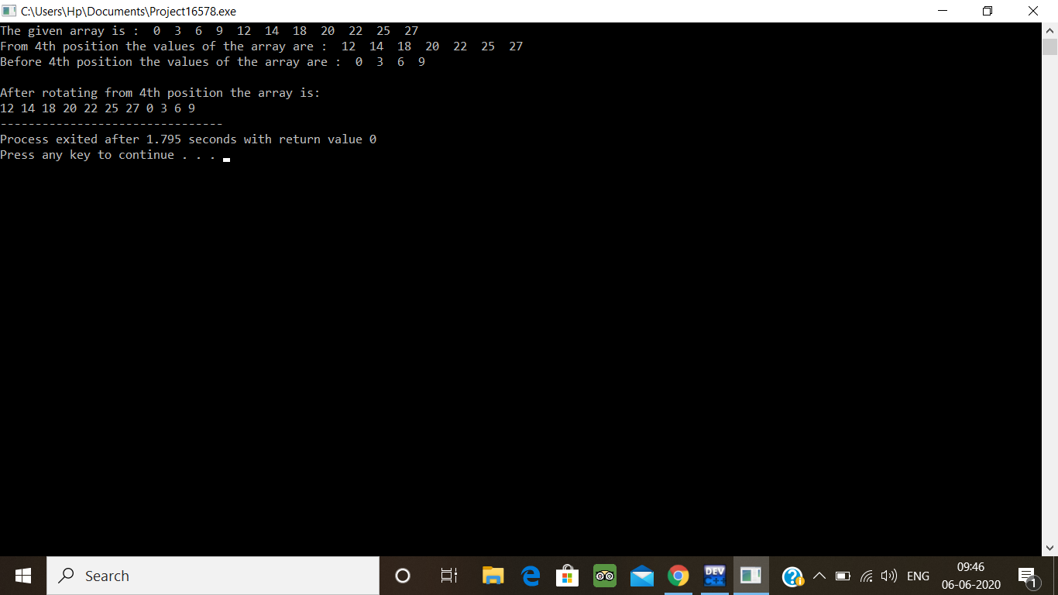

Program 2:

Write a Python program to count the number of strings, provided string length is 2 or more and the first and last character are same from a given list of strings.

